Fresh Try:

Creating the database:

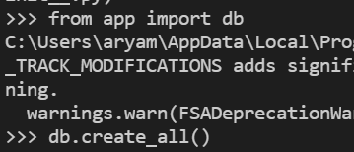

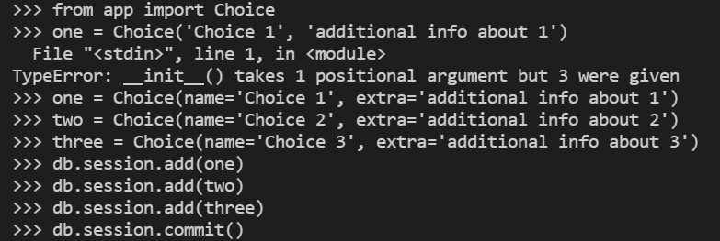



Todo:  
Uninstall all packages and reinstall everything in a virtual environment

pip install virtualenv

pip install qiskit

pip install flask

pip install sqlalchemy

pip install wtforms-sqlalchemy

pip install flask_wtf

You also need sqlite3

After installing sqlite3 and adding it to path, you can see your database

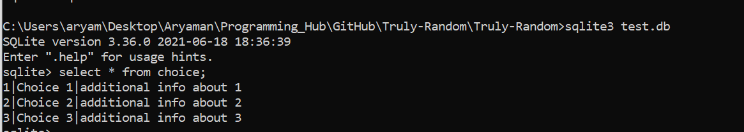

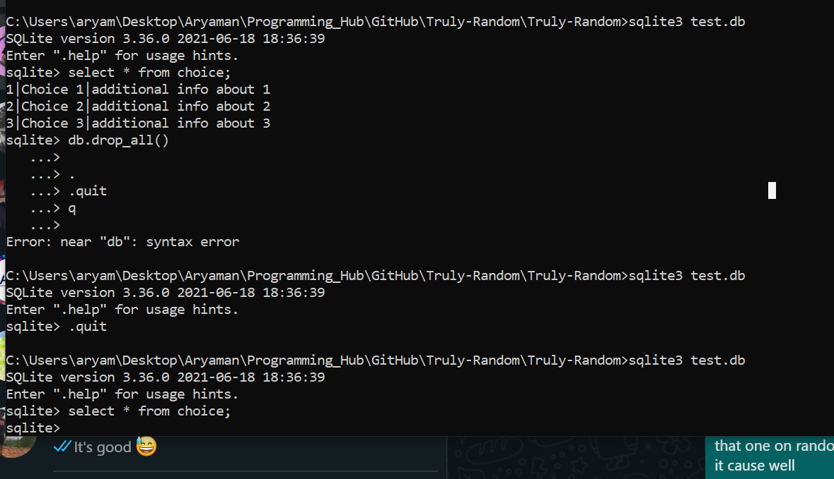

Old Session:

*activate tf*

In tensorflow virtual environment

*pip install qiskit*

Bug?

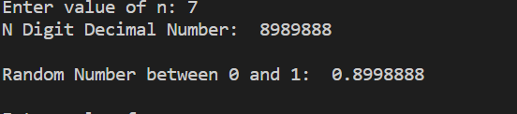

High correlation between n digit number and float from 0 to 1. Only choosing between 8 and 9

FROM ACM Web Dev

Exception transformer npm

If you’re working on some big project, try yarn instead of npm

Use netlify to host the API (Quantum RNG)

Lambda function / web functions/

Alternatives to netlify:

Checkout vercel

Heroku

Firebase